**Source Code Method (ControllerKelolaBuku)**

Object source = ae.getSource();

if (source.equals(kelolaBuku.getTambahBukuBtn())){

ControllerInputBuku obj = new ControllerInputBuku();

} else if (source.equals(kelolaBuku.getLihatBukuBtn())){

ControllerDetailBuku obj = new ControllerDetailBuku();

} else if (source.equals(kelolaBuku.getUbahBukuBtn())){

ControllerEditBuku obj = new ControllerEditBuku();

} else if (source.equals(kelolaBuku.getHapusBukuBtn())){

hapusBuku(id,buku);

} else if (source.equals(kelolaBuku.getCariBukuBtn())){

cariBuku(id);

} else if (source.equals(kelolaBuku.getMenuBtn())){

ControllerMenuAdmin = new ControllerMenuAdmin();

}

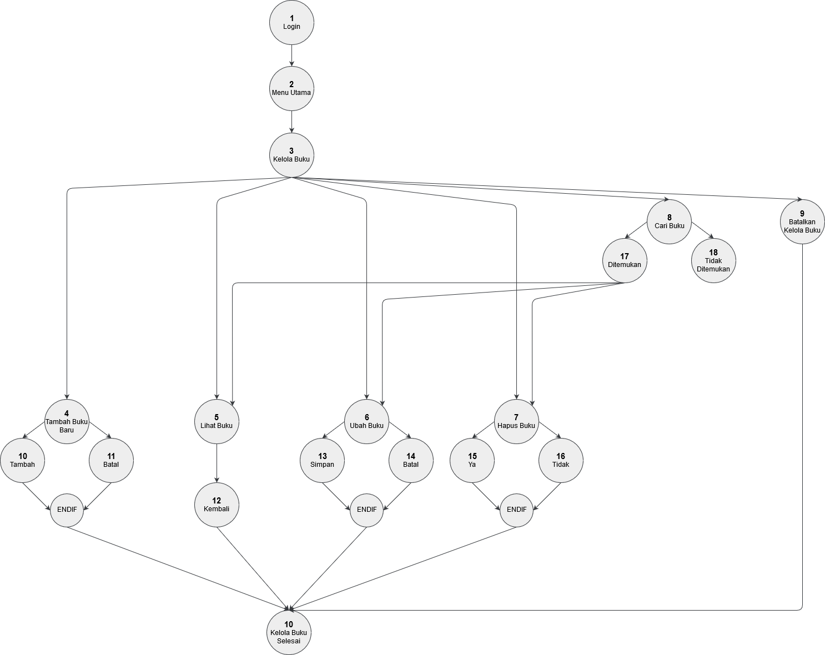

**Cyclomatic Complexity**

V(G) = 13

**Independent Paths**

|  |  |
| --- | --- |
| **Path** | **Flow** |
| Path 1 | 1,2,3,4,10,19 |
| Path 2 | 1,2,3,4,11,19 |
| Path 3 | 1,2,3,5,12,19 |
| Path 4 | 1,2,3,6,13,19 |
| Path 5 | 1,2,3,6,14,19 |
| Path 6 | 1,2,3,7,15,19 |
| Path 7 | 1,2,3,7,16,19 |
| Path 8 | 1,2,3,8,17,5,12,19 |
| Path 9 | 1,2,3,8,17,6,13,19 |
| Path 10 | 1,2,3,8,17,6,14,19 |
| Path 11 | 1,2,3,8,17,7,15,19 |
| Path 12 | 1,2,3,8,17,7,16,19 |
| Path 13 | 1,2,3,9,19 |